PROTOCOL FOR CALIBRATING SOUND OUTPUT PARTICLE VELOCITY
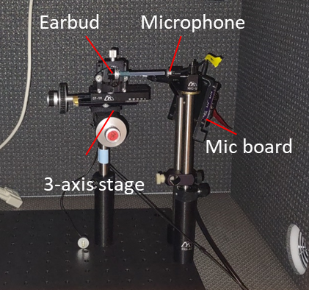
Before starting: Find a quiet room or soundproof box to set up your equipment. You will need your earbuds, sound amplifier and NI-DAQ set up in the same configuration as for sound presentation on the 2-photon microscope. Find a way to position your earbuds and microphone securely, e.g. with optical table rods, rod holders, rails and breadboards. Recommended to attach your earbud to a 3-axis stage (e.g. Siskiyou DT-130) for fine positioning here and on the 2p rig. I attached a small screw to the side of one earbud using cyanoacrylate glue, screwed on a nut and screwed the earbud onto the stage. Ensure that the earbuds is pointing away from walls or solid objects, as we need to minimize sound reflections picked up by the mic.
Insert 3 Ni-MH AAA rechargeable batteries in the battery slots on the microphone board. It is important to ONLY use Ni-MH and not other battery types as their voltages are different, and the voltage is crucial to determine the mic amplifier board's output. Make sure the batteries are well charged, and remove them when not in use.
In the matlab script 'spk_pv_measuring.m', change the 'path' variable on line 3 to the path for your microphone calibration mat file. The file name for the calibration files for microphone sent to the Dacks lab is 'pvusb_4spare_mic_correct_so_attens_calibrated'. In the 'measure_pv' matlab function in the 'PlaySound_MeasurePv' folder, change the 'pv_usb_port' to the port of your microphone board. You can check which port it is using by plugging it in and typing 'serialportlist' in the matlab console.
Protocol:
- Set up earbuds and particle velocity microphone such that the end of the earbud tube is 2.2 mm away (using Vernier calipers) from the front of the particle velocity microphone and properly centered. This will position the tube 3 mm away from the membrane of the mic, which will be the same distance as the distance to the fly's antennae in sound presentation experiments.
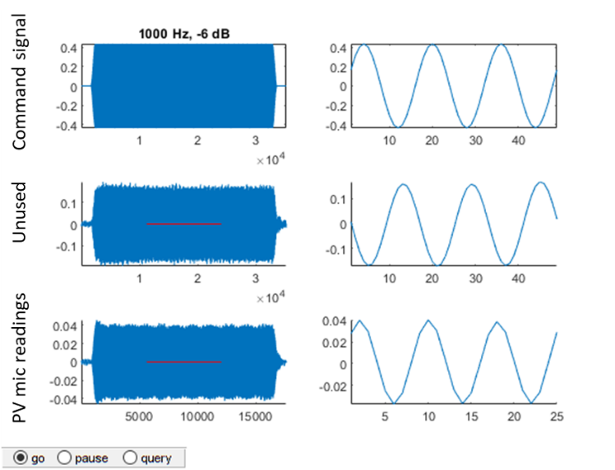
- Run the 'spk_pv_measuring.m' matlab script. It will play a range of pure tones from 100 to 1000 Hz with increasing attenuation (decreasing volume). A window will appear showing the NI-DAQ output to the sound amplifier (first row) and the sound input received by the microphone (third row). The second row is unused. On the first run, you need to adjust the gain on your sound amp so that the vast majority of tones received by the microphone are not clipping or distorting, and look like clean sine waves at the lower attenuations. Clipping/distortion happens at microphone output voltages of roughly 1 V and above (y-axis on third row of window). I accepted some distortion/clipping at the lowest attenuation (highest volume) for some frequencies, but we need to manually exclude those samples later (write the frequency/attenuation combos down once you decide on a gain). Once you have adjusted the gain on your amp, note it down. You need to keep the exact same gain for future experiments. Upon finishing, this first run will generate a file called "koss_sparkplug_freq_response_pv_1.mat" in the script folder. Delete it as this is just a test run.
- To collect real calibration data, run the script at least 3 times (up to 5). Between each run, move the earbuds away and back to 2.2 mm from the mic. This is to take into account variations in earbuds positioning in your calibration. Move the new mat files to a new folder in the ‘koss sparkplug calib’ folder. The new folder can be named anything (e.g. ‘pv mic response’).
- To process the calibration data, use the 'process_mat.R' R script. On line 5, change 'dat_dir' to the path with your saved mat files from step 3. If there were frequency/attenuation combinations that are clipping, exclude them on lines 34-36. Run the script. It should output three files in your default R path (usually My Documents): earbuds pv calib curves.pdf, earbuds pv calib lin fit.pdf, koss_sparkplug_calib_lookup.csv. Take a look at 'earbuds pv calib curves.pdf'. The particle velocity should increase linearly with the voltage multiplier (calculated from attenuation) up to the point the mic or earbuds starts clipping/distorting. Now take a look at ‘earbuds pv calib lin fit.pdf’. This is a linear fit for each frequency, excluding points that you determined to be clipping/distorting. Make sure that the points you are fitting the line to do indeed look linear. The 'koss_sparkplug_calib_lookup.csv' contains the slope of these lines, which we will use to determine the particle velocity of the earbuds output. Move it to the 'koss sparkplug calib' folder that is in the same folder as the 'PlaySound_MeasurePv' folder. Now you can use the play_sound function to output pure tones of known particle velocity. Typical dynamic range for Drosophila hearing is 0.001 m/s or less.
